

CZ4042 Neural Networks

31st October 2017

Assignment 2

**Quek Zhe Yu**

**Bryant Khoo**

**Computer Specifications:**

**Macbook Pro Retina 15” 2015**

**2.2GHz Intel Core i7**

**Supervised By –**TA Mr. Sukrit Gupta  
School of Computer Science and Engineering, Nanyang Technological University

Table of Contents

Executive Summary 2

1. Object Recognition in Images 2

1.1. Introduction to CNN 2

1.1.1. Basic Concepts 2

1.1.2. Basic Structure 3

1.2. Design a Convolutional Neural Network (SGD) 4

1.2.1. Implementation of CNN 5

1.2.2. Plots 6

1.3. Momentum Term in SGD 8

1.4. RMSProp Algorithm 8

2. Approximation Problem – Housing Prices in California 8

# Executive Summary

The objective of this project is to gain exposure to the use of neural network to real-world problems like object recognition in images using Convolutional Neural Networks (CNN) and gain insights with the use of autoencoders to denoise corrupted data.

# 1. Object Recognition in Images

## 1.1. Introduction to CNN

Convolutional Neural Networks are designed for image recognition, where the architecture allows us to encode certain properties into the architecture and make the forward function more efficient to implement and vastly reduce the amount of parameters in the network.

CNN takes advantage of the fact that the input consists of images and they constrain the architecture in a more sensible way. The layers of a CNN have neurons arranged in 3D: **Width, Height and Depth.**

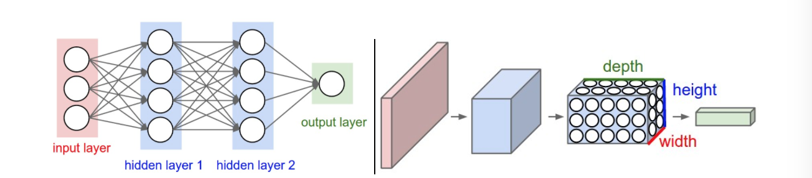

Figure 1: Comparison between regular NN and CNN architectures

On the left of figure ___ represents a regular 3-layer Neural Network, while the right shows the CNN arranging it neurons in 3D. Every layer has a simple API which transform an input 3D volume to an output 3D volume of neuron activations.

### Basic Concepts

To understand more about how CNN works, we must understand the details of neuron connectivity and their parameter sharing scheme.

#### Local Connectivity

We connect each neuron to only a local region of input volume. The spatial extent of this connectivity is a hyperparameter called the **receptive field of the neurons (filter size).** This vastly reduces the amount of feedforward and backpropagation computations.

#### Parameter Sharing

In CNN, each filter is replicated across the entire visual field. These replicated units share **same parameterization (weight vector and bias) and form a feature map**. Replicating weights in this ways allows for features to be detected regardless of the position in the visual field. Additionally, weight sharing increases learning efficiency by greatly reducing the number of free parameters.

### Basic Structure

With an example for illustration, a basic structure of a CNN architecture would involve:

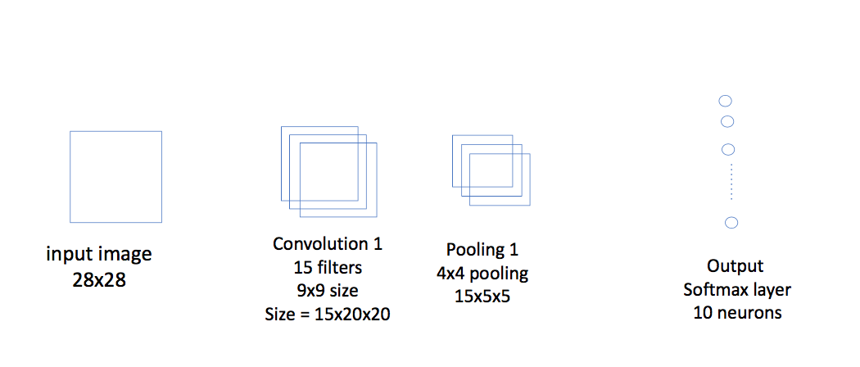

Figure 2: Basic Example of CNN architecture

|  |  |
| --- | --- |
| Layer | Function |
| Input | * Contains the data for the raw pixel values of the image of size 28x28 |
| Convolutional Layer | * Learn the features over small patches of images and the learned features (filters) are convolved with the image to obtain feature activations (maps). * Features or the weights can be learned using feature detectors or backpropagation algorithm. * The region of the input layer that is connected to a layer is referred as the receptive field. The features or weights learned are known as filters or kernels. The activations are obtained by convolving the filters (weights) with the input activations. The output activation learned by a particular filter is known as a feature map. * Each Feature map Size = 9x9 dimension * Output = 15 Features Maps of Size 20x20 |
| Pooling Layer | * Perform a down-sampling operation along the spatial dimension. * Each Pool size = 4x4 dimension * Output = 15 Feature Maps of Size 5x5 |
| Fully Connected | * Final layers of deep CNN can consist of one or more fully connected layers. The output layer is usually a softmax regression layer for classification. * Output = 10 neurons |

## 1.2. Design a Convolutional Neural Network (SGD)

In this assignment, we need to design a CNN of the following characteristics:

|  |  |
| --- | --- |
| Layer | Characteristics |
| Input | Size: 28x28 |
| Convolutional Layer C1 | 15 Feature Maps  Size: 9x9 |
| Pooling Layer S1 | Size: 2x2 |
| Convolutional Layer C2 | 20 Feature Maps  Size: 5x5 |
| Pooling Layer S2 | Size: 2x2 |
| Fully Connected F3 | Size: 100 |
| Softmax Layer F4 | Size: 10 |

Figure 3 illustrates the architecture of our CNN:

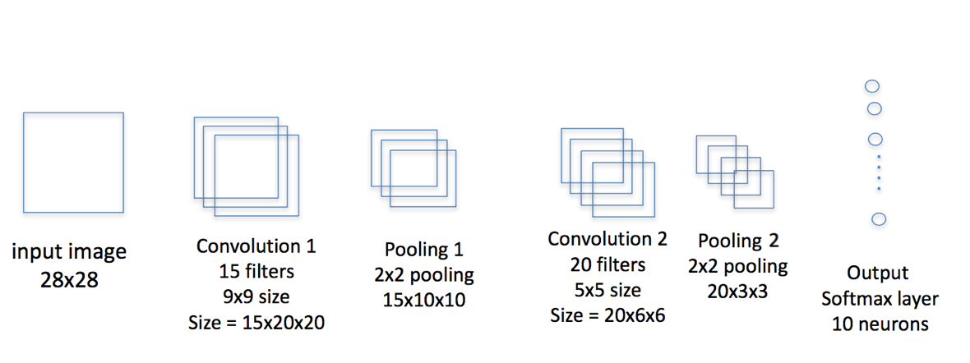

Figure 3: CNN architecture for assignment

We are supposed to train the network using ReLu activation functions for neurons and mini batch gradient descent learning.

### 1.2.1. Implementation

Setting the batch size at 128, learning rate 𝛼 = 0.05 and decay parameter 𝛽 = 10-4, we implement the CNN as follows:

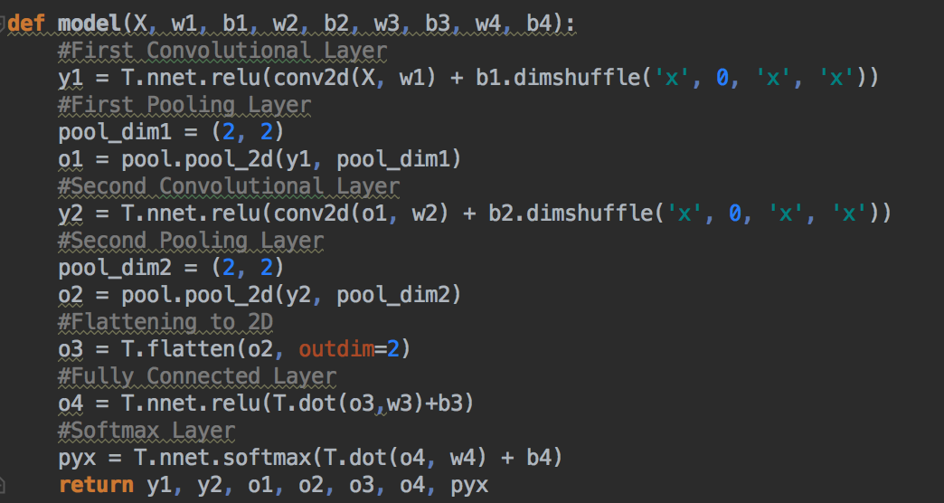

Figure 4: CNN Model in python

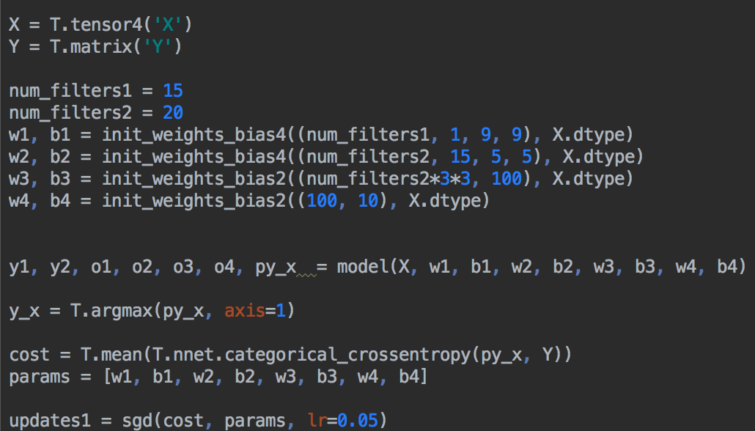

Figure 5: Weights and Outputs configurations

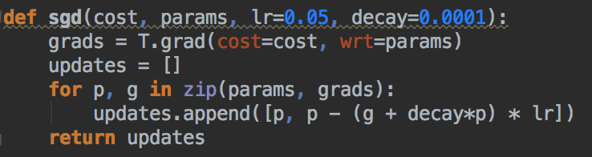

Figure 6: SGD Implementation

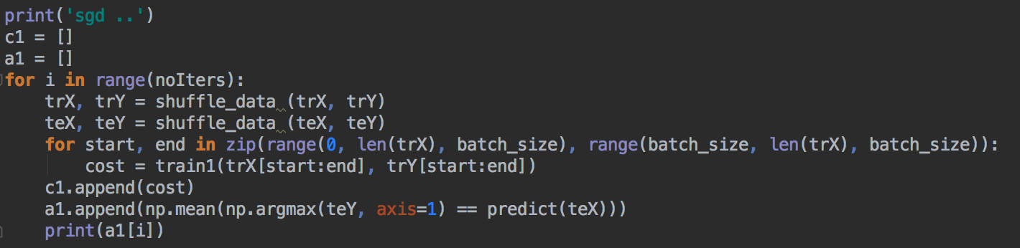

Figure 7: Trainings of CNN Model in mini batches

### 1.2.2. Plots

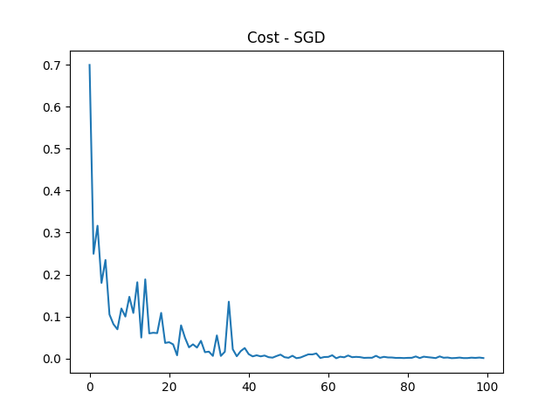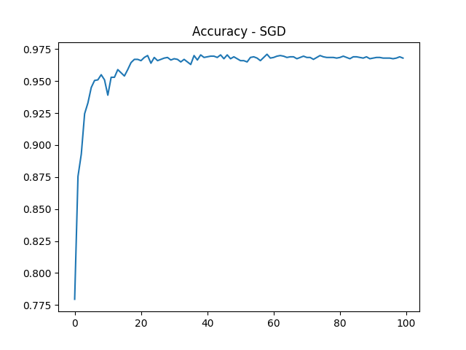

Figure 8: Plotting of training cost and test accuracy with learning epochs

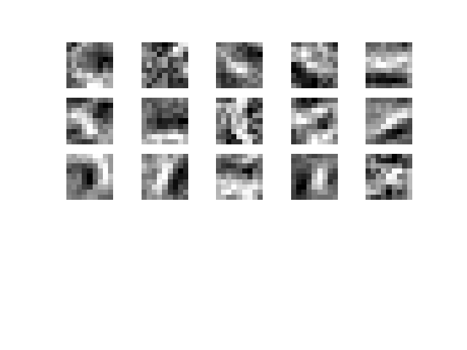

Figure 9: Features learned by the first convolution layer

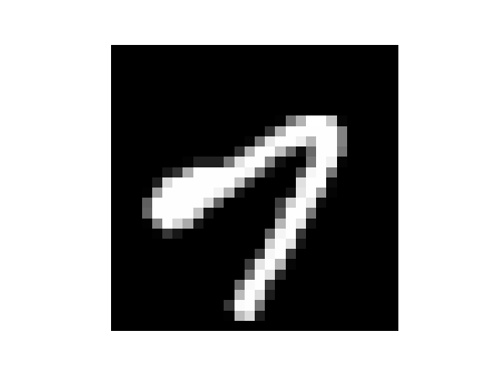

Figure 10: Input image

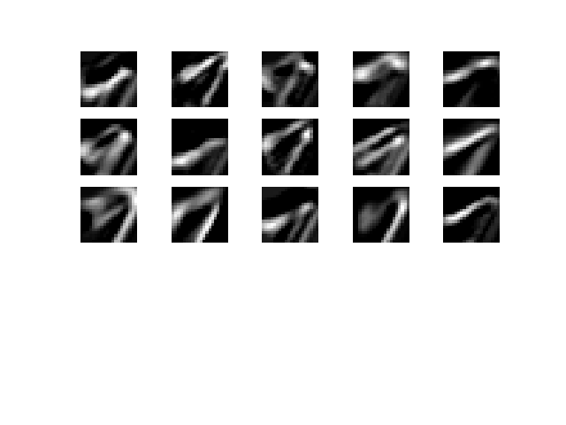  
Figure 10: Feature maps at first convolution layer 15x20x20

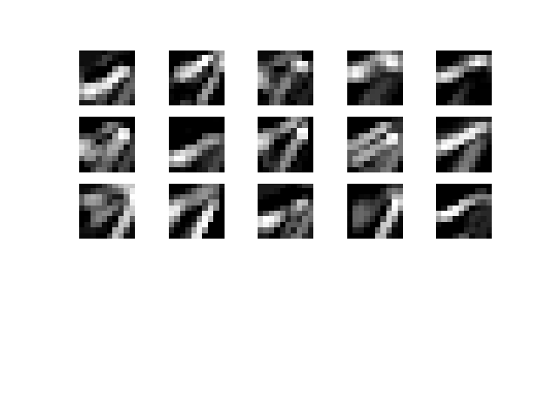

Figure 11: Feature maps at first pooling layer 15x10x10

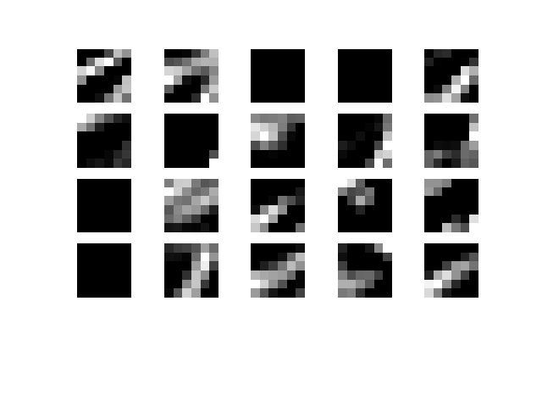

Figure 12: Feature maps at second convolution layer 20x6x6

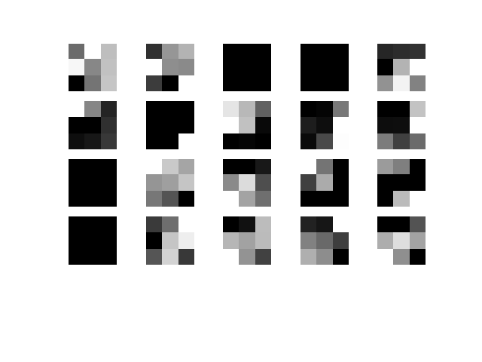

Figure 13: Feature maps at second pooling layer 20x3x3

## Momentum Term in SGD

The method of momentum is designed to accelerate learning. The momentum algorithm accumulates an exponentially decaying moving average of past gradients and continues to move in their direction. It is one method of speeding the convergence.

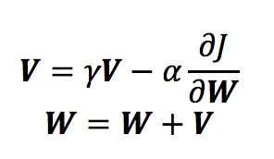

**V** is known as the velocity term and has the same dimension as the weight vector **W**. The momentum parameter indicates how many iterations the previous gradients are incorporated into the current update

### 1.3.1. Implementation

In our implementation, we added a momentum parameter 𝛾 = 0.1:

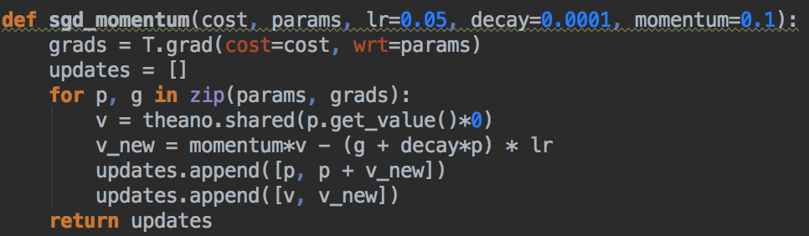

Figure 14: Implementation of SGD with Momentum

### 1.3.2. Plots

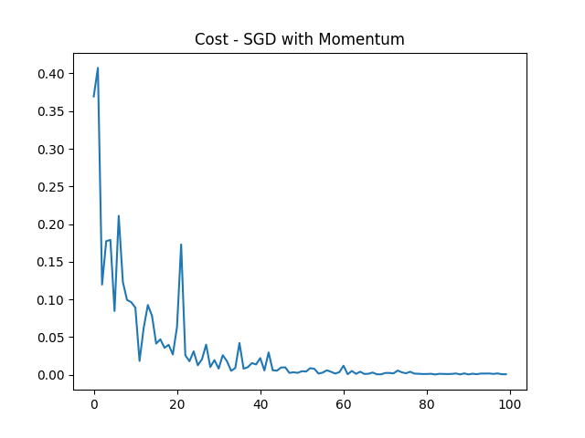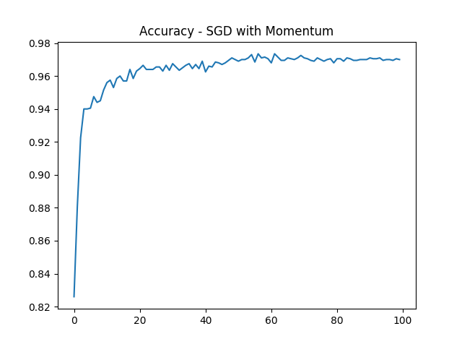

Figure 15: Plotting of training cost and test accuracy with learning epochs

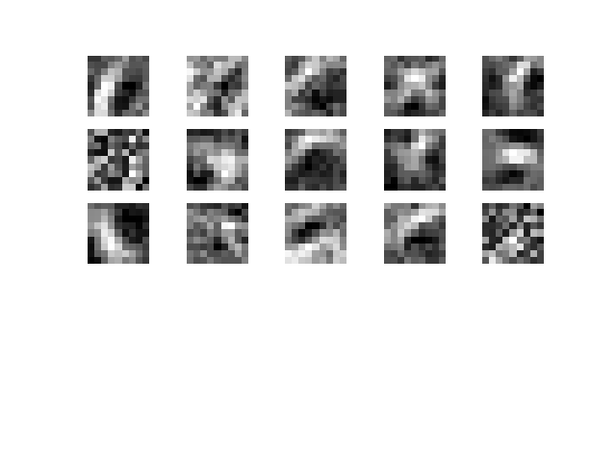

Figure 16: Features learned by the first convolution layer

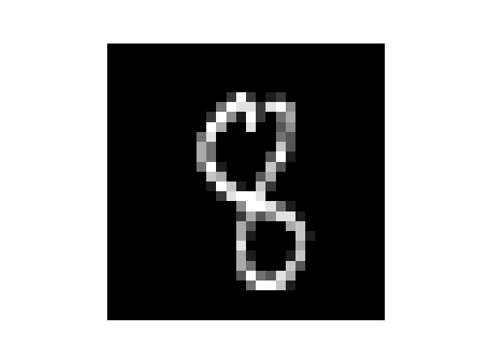

Figure 17: Input Image

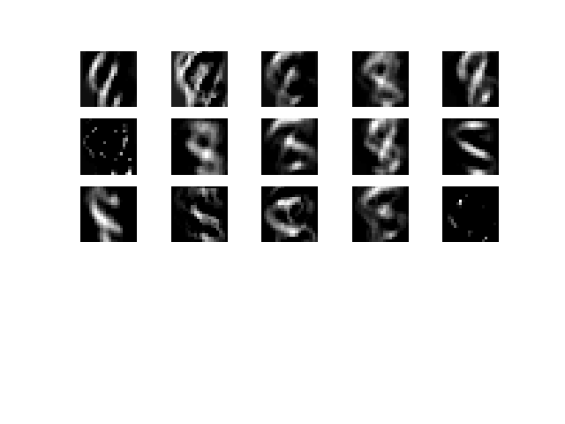

Figure 18: Feature maps at first convolution layer 15x20x20

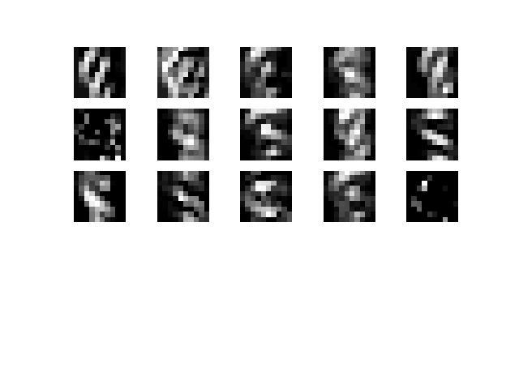

Figure 19: Feature maps at first pooling layer 15x10x10

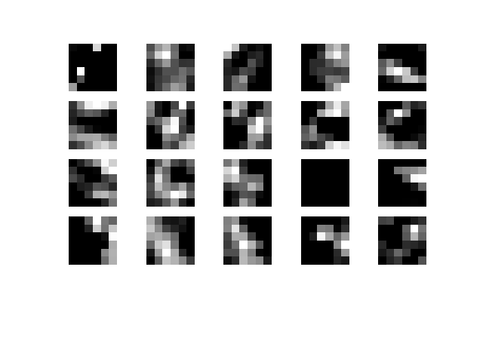

Figure 20: Feature maps at second convolution layer 20x6x6

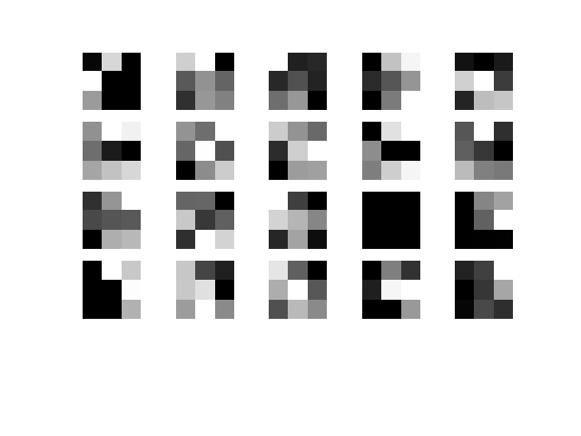

Figure 21: Features learned by the second pooling layer 20x3x3

## RMSProp Algorithm

RMSProp is a gradient descent optimization algorithm that uses an exponentially decaying average to discard the history from extreme past so that it can converge rapidly after finding a convex region.

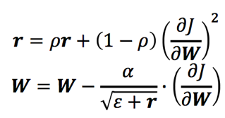

𝜌, 𝛼 and 𝜖 are parameters to be determined empirically

RMSProp has been shown to be an effective and practical optimization algorithm for deep neural network

### Implementation

Hence, we implement the RMS algorithm using 𝛼 = 0.001, 𝛽 = 1𝑒−4 , 𝜌 = 0.9,  and 𝜖 = 10−6 for RMSProp.

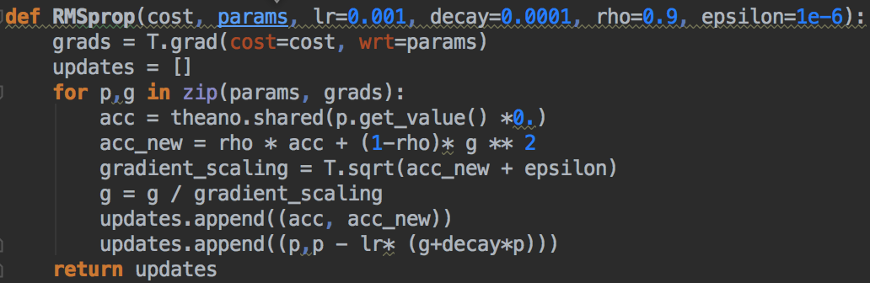

Figure 22: RMSProp Implementation

### 1.4.2. Plots

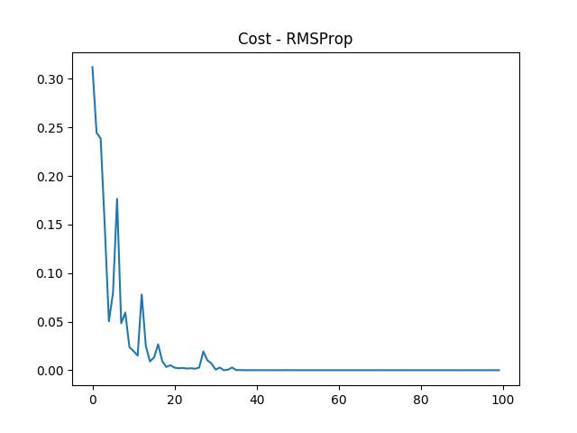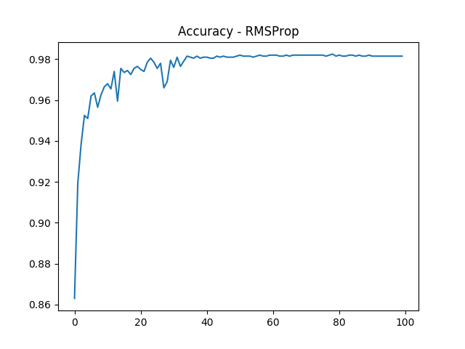

Figure 23: Plotting of training cost and test accuracy with learning epochs

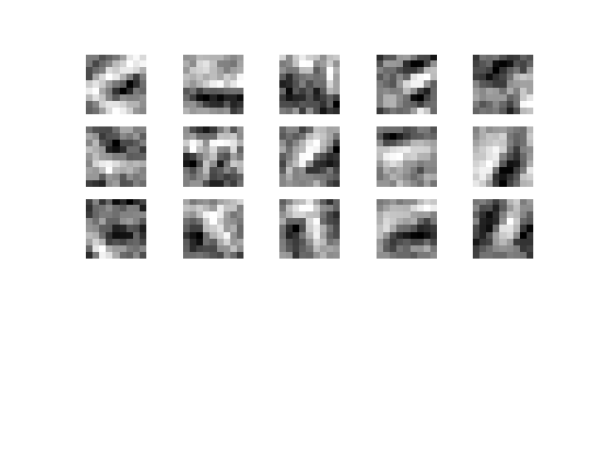

Figure 24: Features learned by the first convolution layer

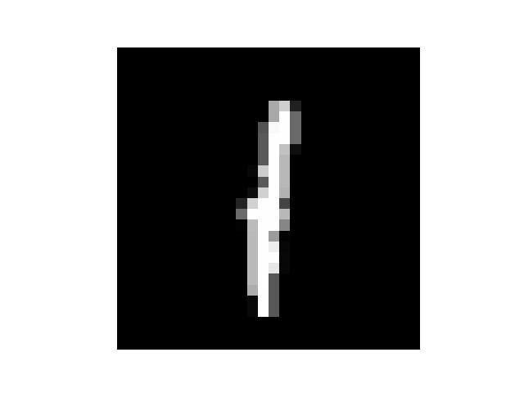

Figure 25: Input Image

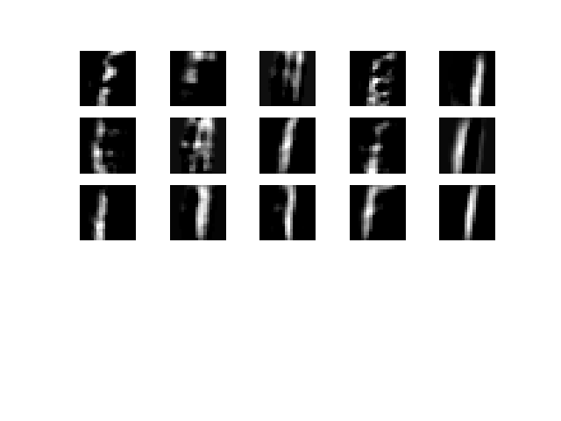

Figure 26: Features maps of first convolution layer 15x20x20

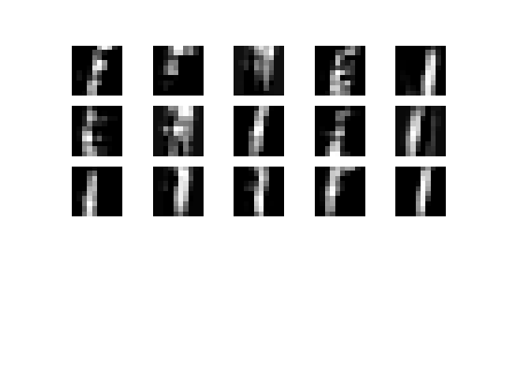

Figure 27: Feature maps at first pooling layer 15x10x10

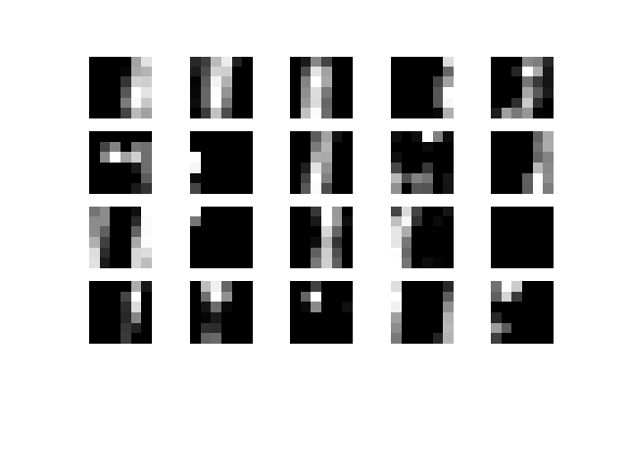

Figure 28: Feature maps at second convolution layer 20x6x6

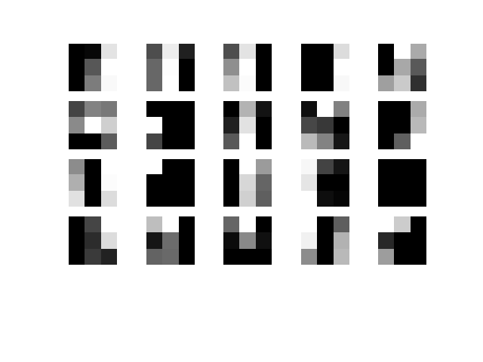

Figure 29: Feature maps at second pooling layer 20x3x3

## Evaluation

As seen in Figure 30, we compare the cost and accuracies across the various algorithms. The algorithm with the lowest cost and highest accuracy is the RMSProp Optimizing Algorithm.

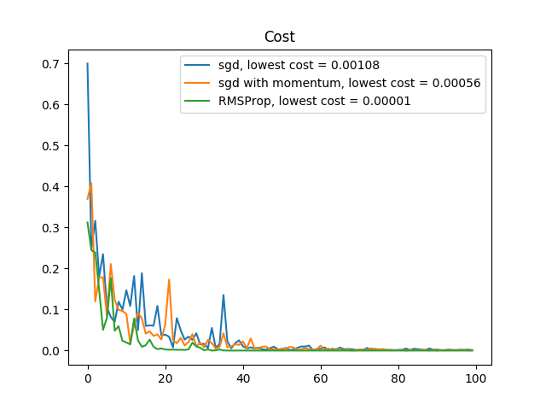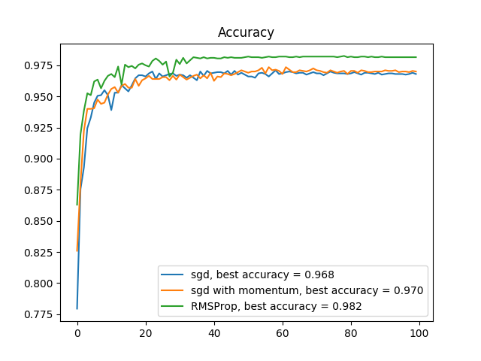

Figure 30: Plotting of training cost and test accuracy with learning epochs

# 2. Autoencoders with the MNIST dataset

## 2.1. Stacked Denoising Autoencoder

### 2.1.1. Introduction to Autoencoders

An autoencoder neural network is an unsupervised learning algorithm that applies backpropagation, and is trained attempt to copy its input to its output. The hidden layer of an autoencoder describes a compressed representation (code) of the input.

The network consists of an encoder and decoder. The encoder compresses the input and produces the code, and the decoder reconstructs the input only using this code.

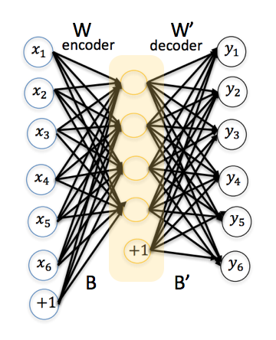 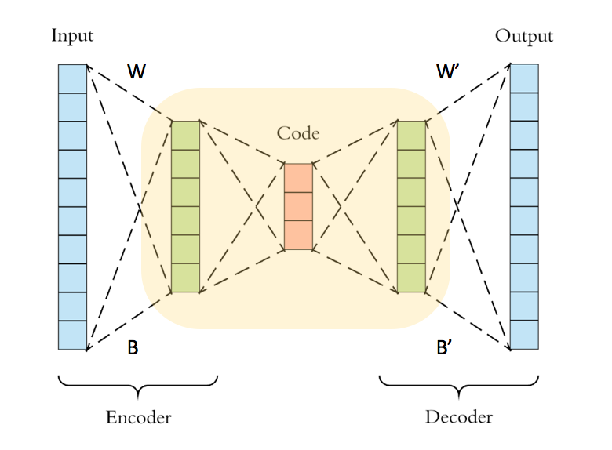

Figure 31: Autoencoder with 1 hidden layer

Given an input, the hidden layer performs the encoding function and the decoder produces the reconstruction. The following illustration shows how this is done in an autoencoder with one hidden layer. For this project, we will be designing a stacked denoising auto encoder consisting of three hidden layers.

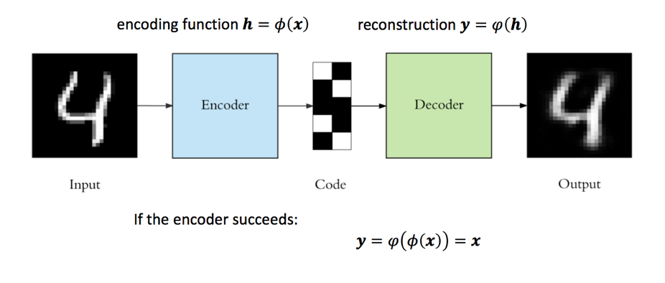

Figure 32. Example encoding and reconstruction with 1 hidden layer

### 2.1.2. Design a stacked denoising autoencoder

For this assignment, we are tasked to design a stacked denoising autoencoder with the following characteristics.

|  |  |
| --- | --- |
| Layer | Characteristics |
| Input | Size: 28x28 |
| Hidden Layer h1 | 900 Neurons |
| Hidden Layer h2 | 625 Neurons |
| Hidden Layer h3 | 400 Neurons |

For all the training of all layers, we will be using the following training parameters.

|  |  |
| --- | --- |
| Parameter | Value |
| Corruption level | 0.1 |
| Training Epochs | 25 |
| Learning Rate | 0.1 |
| Batch Size | 128 |

### 2.1.3. Implementation

Figure 33 depicts the Architecture of our stacked denoising autoencoder. It shows the encoder and decoder portion of the autoencoder, including the respective weights and biases. The matrix sizes are also included to provide clarity.

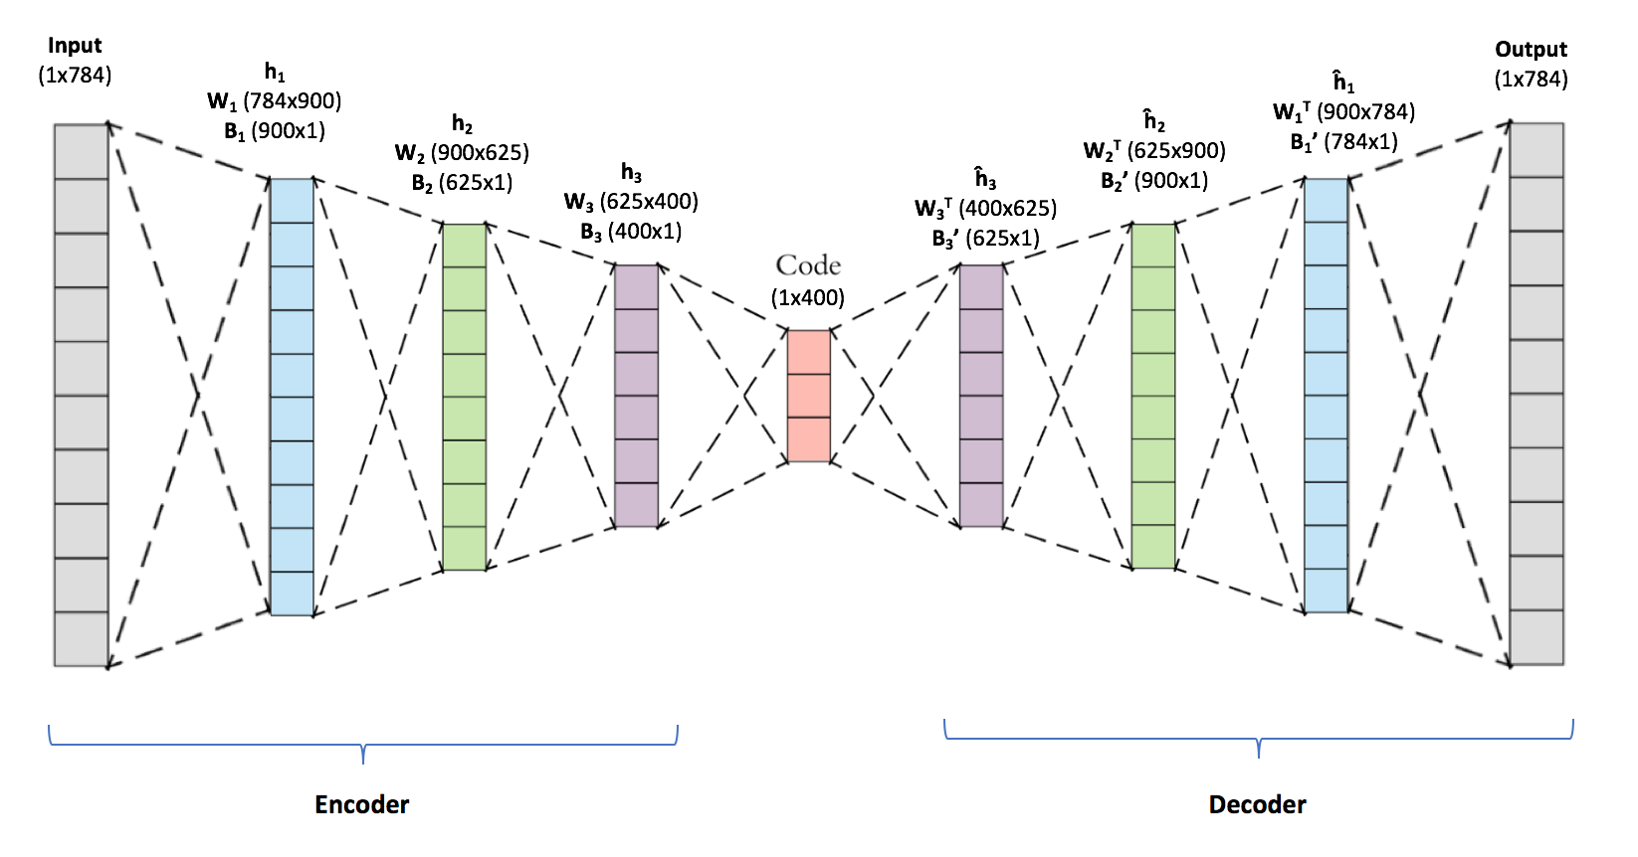

Figure 33. Architecture of our Stacked Denoising Autoencoder

Figure 34. to Figure 36. below is a code snippet of our implementation of the first hidden layer.

With knowledge on the number of neurons in each hidden layer, we are able to decide on the size on the matrices required for the weights and bias.

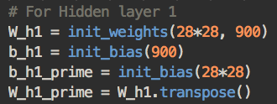

Figure 34. Initializing Weights and Bias for first hidden layer

Next, we define the outputs of our encoder and decoder for our first hidden layer, with respect to the previously initialized weights and bias. *y1* is the hidden activations of the encoder, and *z1* is the output of the decoder. *tilde_x* is used to corrupt the input data with a binomial distribution at 10% corruption level.

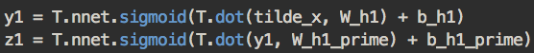

Figure 35. Initializing Weights and Bias for first hidden layer

Since the inputs are interpreted as a bit vector, we use cross-entropy of the reconstruction for our cost function. Similarly, the cross-entropy of construction can be used for cost functions for hidden layer 2 and 3.



Figure 36. Cost function for hidden layer 1

We also indicate W1, B1 and B1’ as the parameters to update with gradient descent learning. W1T will be used for the decoder’s weight matrix.

The following Theano functions are also defined for hidden layer 1:

* train_da1: For training the first hidden layer
* encoder_1: The encoder for hidden layer 1 which encodes inputs x into outputs y1
* decoder_1: The decoder for hidden layer 1 which decodes inputs y1 into outputs z1

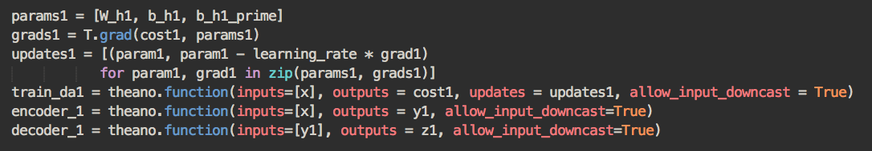

Figure 37. Defining Update parameters and Theano functions

Similarly, we perform the same steps to implement hidden layers 2 and 3. The code snippets

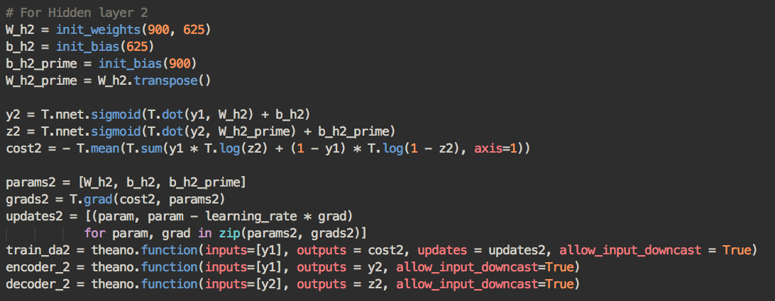

Figure 38. Implementation of hidden layer 2 in Python

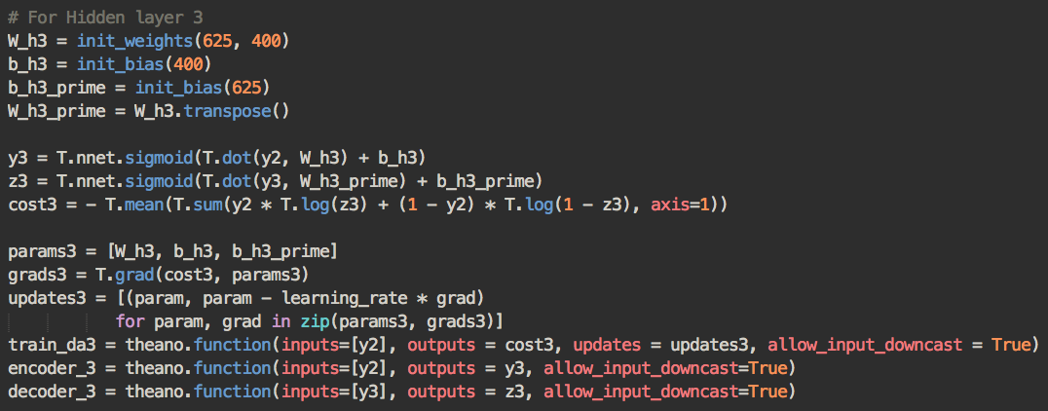

Figure 39. Implementation of hidden layer 3 in Python

Next, we build the stacked denoising autoencoder by stacking autoencoders. After training the first level of denoising autoencoder, we use the representation to train the second level of the denoising encoder. We repeat those steps until the stacked denoising autoencoder with three-hidden layer is realized. For this part of the assignment, trained the network using the full MNIST data.

Figure 39 to 41 illustrates how we trained hidden layers 1 to 3. The result after obtaining a representation of hidden layer 3 is the full architecture that we have shown previously in Figure 33.

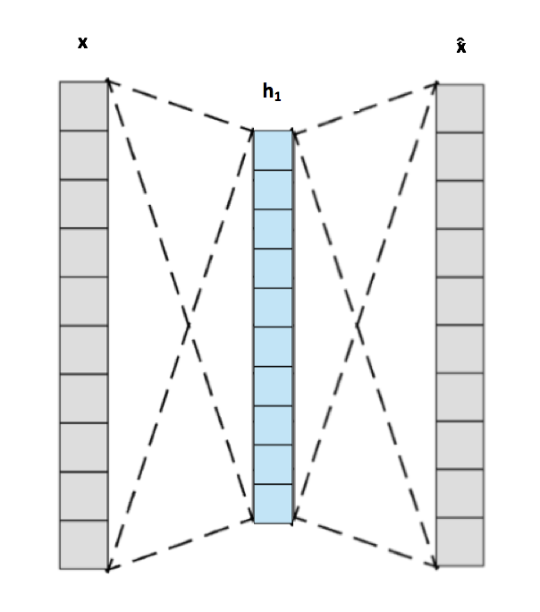

Figure 40. Illustration of training the first hidden layer

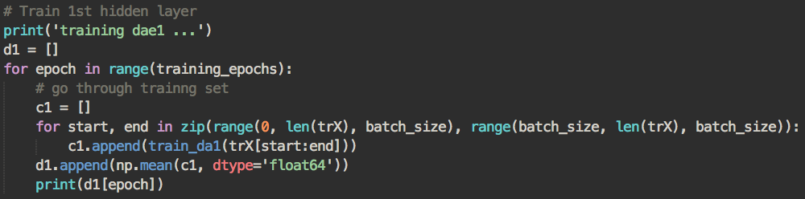

Figure 41. Implementation of training the first layer

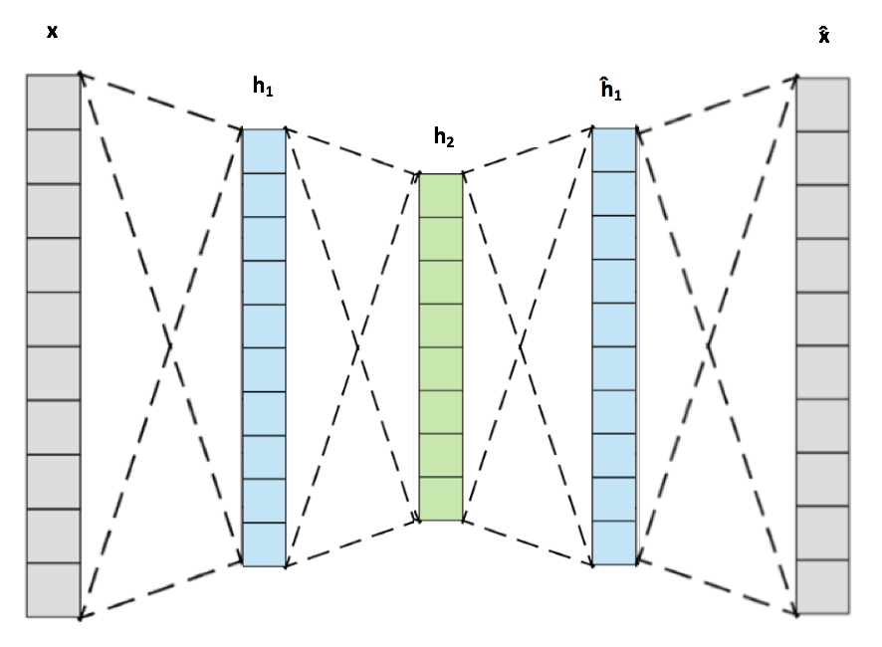

Figure 42. Illustration of training the second hidden layer

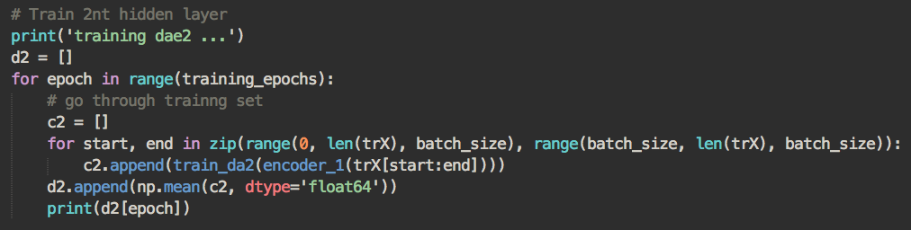

Figure 43. Implementation of training the second layer

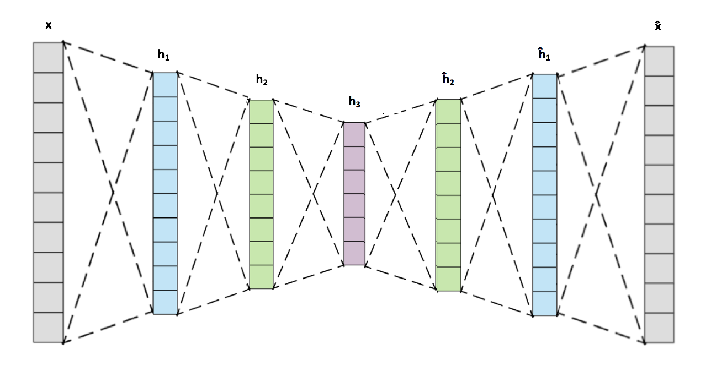

Figure 44. Illustration of training the third hidden layer

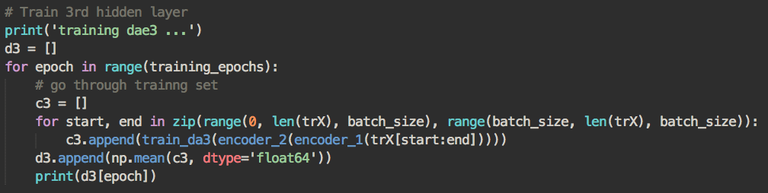

Figure 45. Implementation of training the third hidden layer

### 2.1.4. Learning Curves

We train the first hidden layer as per the code snippet in Fig. 41 and obtain the training curve as follows.

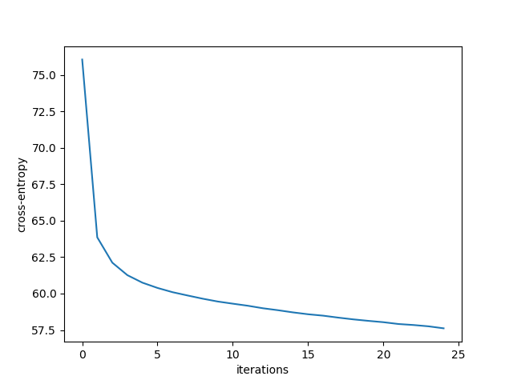

Figure 46. Learning Curves for training first layer

Next, train the second hidden layer as per the illustration in Fig. 42 and code snippet in Fig. 43 and obtain the training curve as follows.

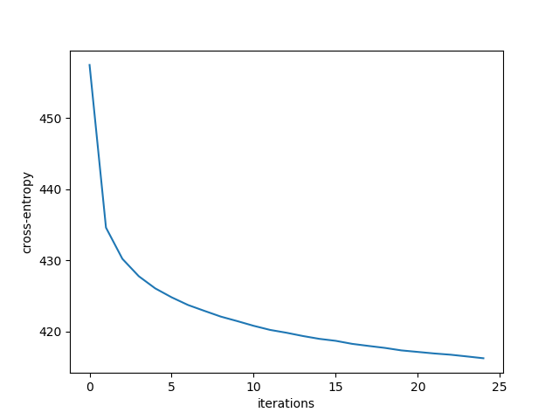

Figure 47. Learning Curves for training second layer

Lastly, we train the third hidden layer as per the illustration in Fig 44 and code snippet in Fig. 45 and obtain the training curve as follows.

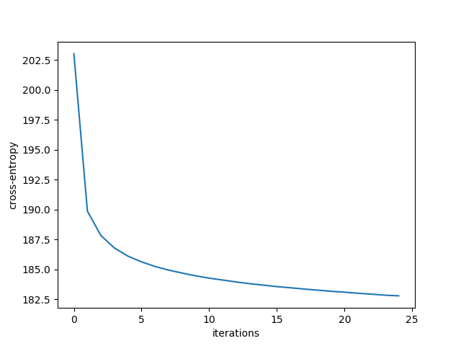

Figure 48. Learning Curves for training third layer

### 2.1.5. Samples of weights

At each layer, we plot 100 samples of weights learned at each layer as images.

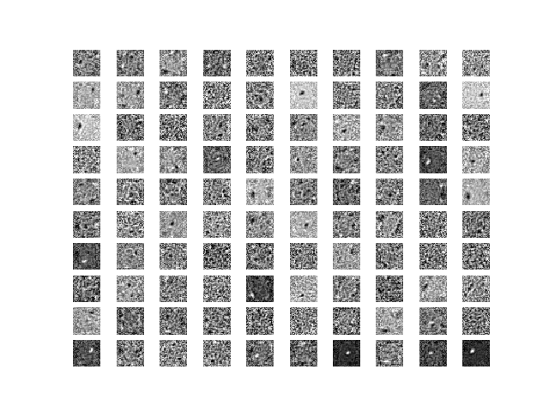

Figure 49. 100 samples of weights (as images) learned at layer 1

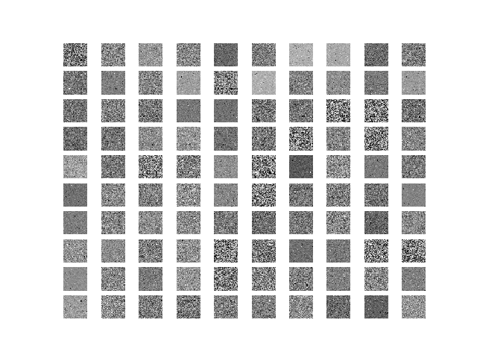

Figure 50. 100 samples of weights (as images) learned at layer 2

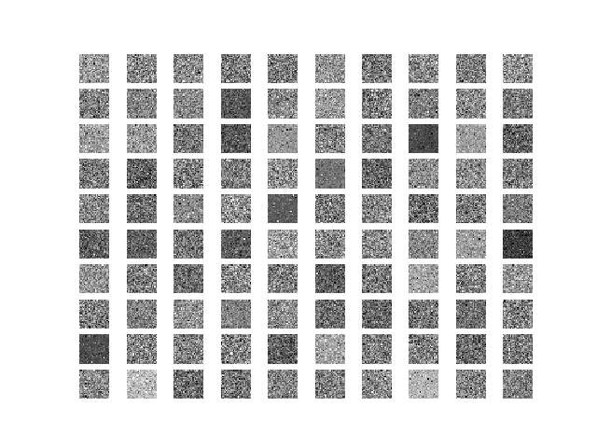

Figure 51. 100 samples of weights (as images) learned at layer 3

### 2.1.6. Reconstructed images

For 100 representative test images, we plot the images reconstructed by our stacked denoising autoencoder.

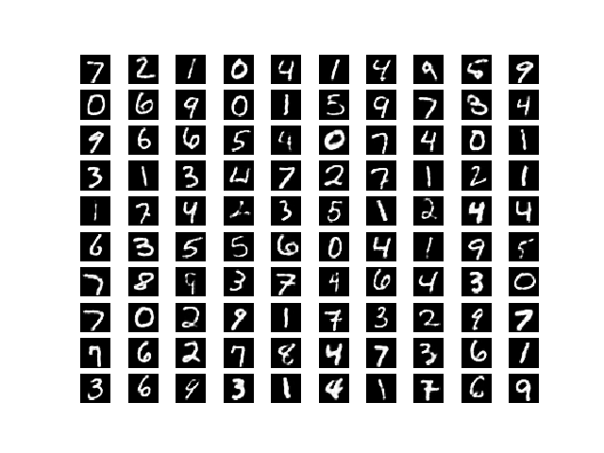

Figure 52. Reconstructed images if 100 representative test images

### 2.1.7. Hidden Layer Activation

For 100 representative test images, we plot the hidden layer activation.

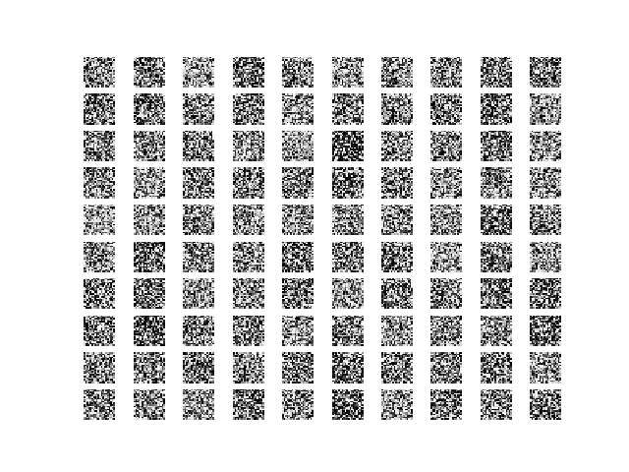

Figure 53. Hidden Layer Activation of Network

## 2.2. Five-layer feedforward neural network

### 2.2.1. Implementation

We train a five-layer feedforward neural network to recognize MNIST data, initialized by the three hidden layers from part 2.1, and by adding a softmax layer as the output layer.

The five-layer feed forward neural network will have an input layer, the three encoders from part 2.1 as the hidden layers, and added softmax layer as the output layer. The architecture of the five-layer feed forward neural network is depicted in Fig 54. below.

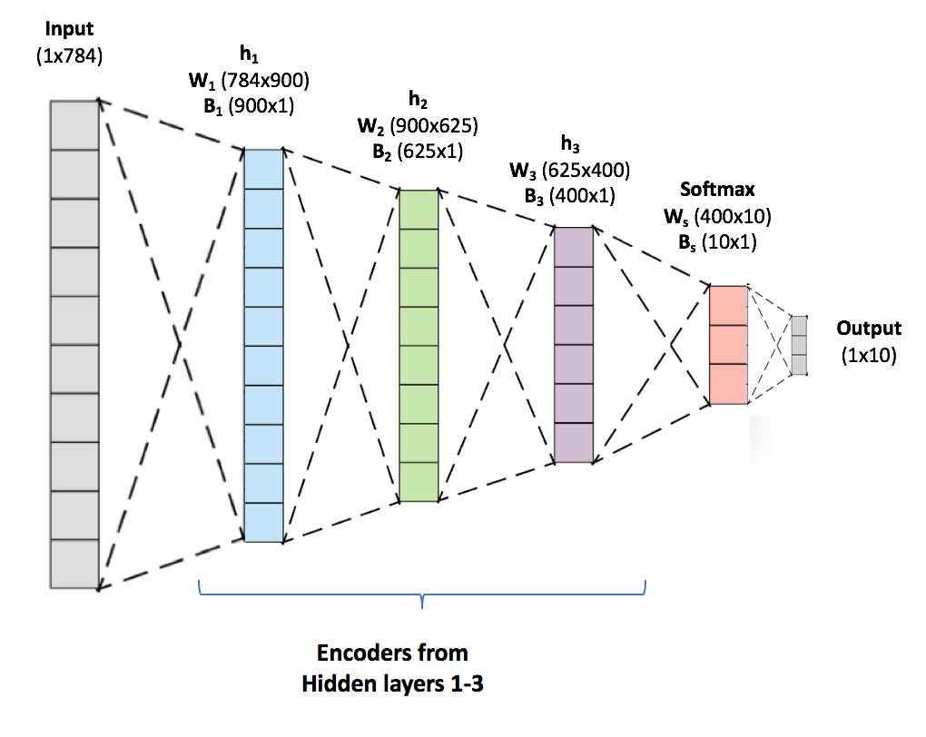

Figure 54. Architecture of 5-layer feedforward Neural Network

As per the architecture, we initialise weights and bias for the softmax layer, and implement the output layer as per our code snippet below in Figure 55.

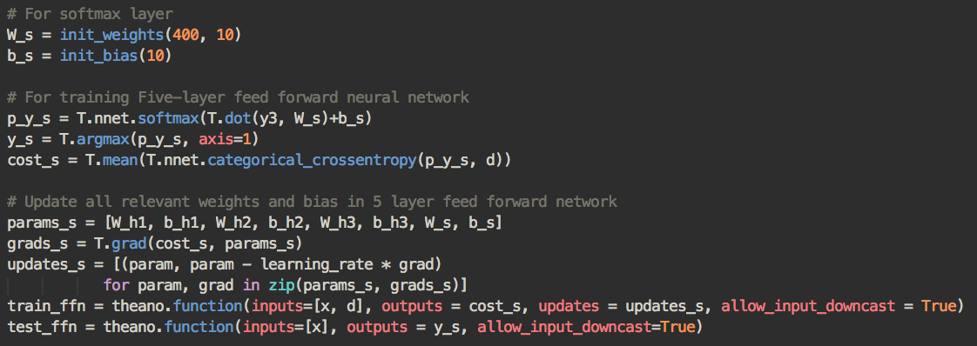

Figure 55. Implementation of softmax layer as output layer

The following code snippet in Figure 56 shows how we will train and test our five-layer neural network.

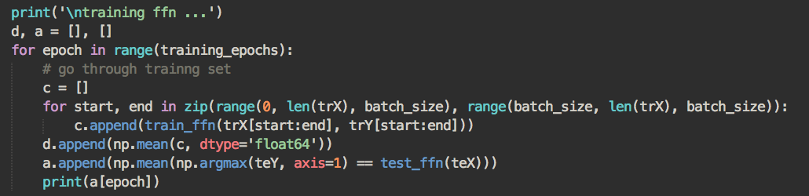

Figure 56. Training and testing 5-layer feedforward network

### 2.2.2. Train error and Test Accuracies

As instructed, we train the five-layer neural network with 25 epochs. We plot the training errors and test accuracies during training to obtain Figure 57 and 58.

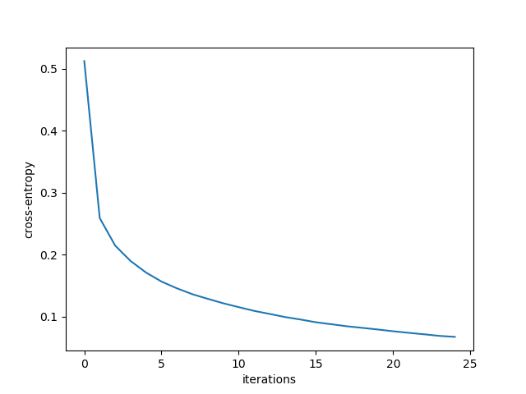

Figure 57. Training and 5-layer feedforward network

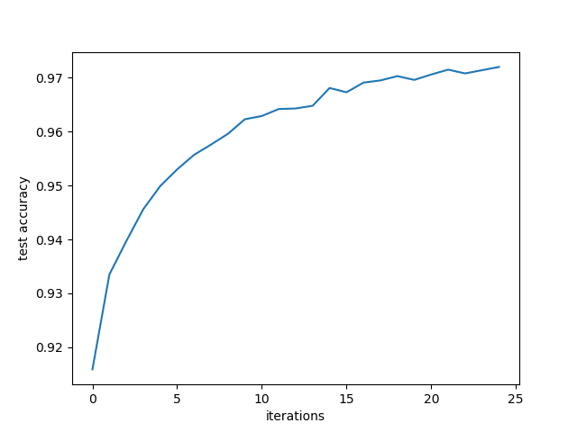

Figure 58. Test Accuracies of 5-layer feedforward network

## 2.3. Introducing Momentum Term and Sparsity Constraints

### 2.3.1. Implementation

The goal of implementing the Momentum term is to speed up the convergence along a narrow ravine. As depicted in the code snippet below, we first calculate *v*, known as the velocity term, which has the same dimension as the weight vector. The momentum parameter is set to 0.1 and it indicates how many iterations the previous gradients are incorporated into the current update.

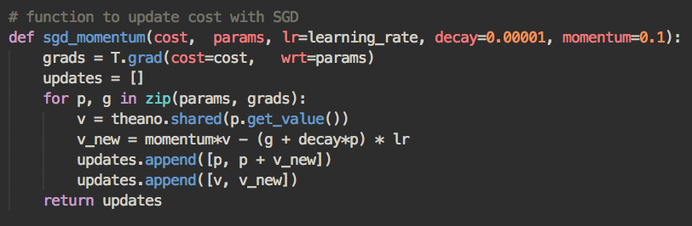

Figure 59. Implementation of Momentum Term in Python

Next, we introduce sparsity constraint to the cost function. A sparse autoencoder is an autoencoder whose training criterion involves sparsity penalties at the **hidden layers**. Thus, we implement the cost functions with sparsity as per Fig 60 to Fig 62.

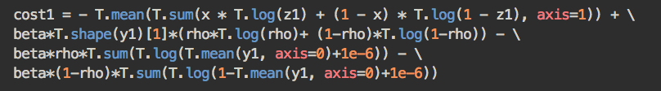

Figure 60. Cost function of hidden layer 1 with sparsity constraint

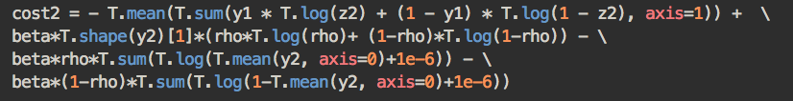

Figure 61. Cost function of hidden layer 2 with sparsity constraint

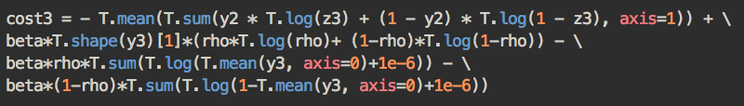

Figure 62. Cost function of hidden layer 3 with sparsity constraint

### 2.3.2. Comparison

Parts (1) and (2) were repeated, to retrain the hidden layers of the autoencoder and training the five-layer feedforward neural network with momentum term for gradient descent learning and sparsity constraint to the cost function. The following parameters were used:

|  |  |
| --- | --- |
| Parameter | Value |
| Momentum Parameter | 0.1 |
| Penalty Parameter | 0.5 |
| Sparsity Parameter | 0.05 |

We compare the results of Part (3) with that of Parts (1) and (2).

### 2.3.2.1 Comparing Learning Curves

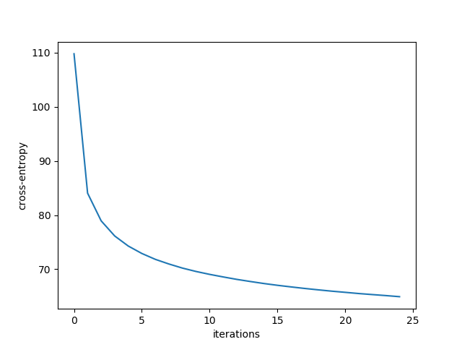

Figure 46 & 47. Learning Curves for training first layer

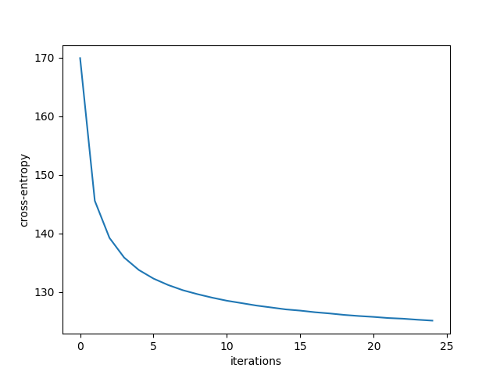

Figure 47 & 48. Learning Curves for training second layer

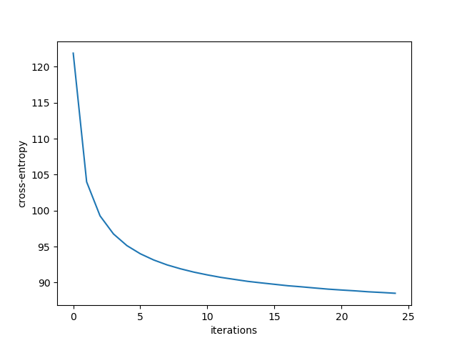

Figure 49 & 50. Learning Curves for training third layer

### 2.3.2.2 Comparing Samples of Weights

Figure 51 to 56 are the plotted weights learned for each layer, we can notice that the weights learnt for Part 3 is sparser than that of part 1. Without the introducing the sparsity constraint, the network is only able to pick up the most important features in Part 1. With sparsity constraint, the weight matrices are also sparse, resulting in more distinct light and dark spots in Figure 52.



Figure 51. (Part 1) 100 samples of weights (as images) learned at layer 1

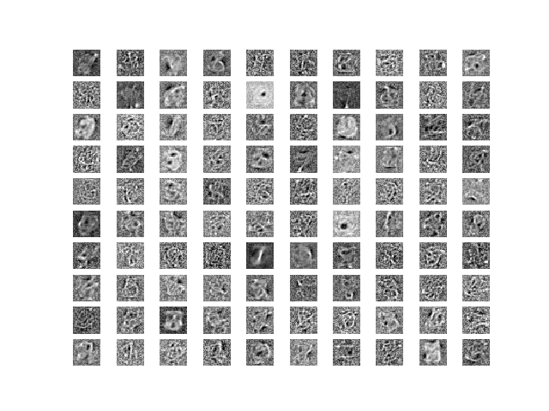

Figure 52. (Part 3) 100 samples of weights (as images) learned at layer 1



Figure 53. (Part 1) 100 samples of weights (as images) learned at layer 2

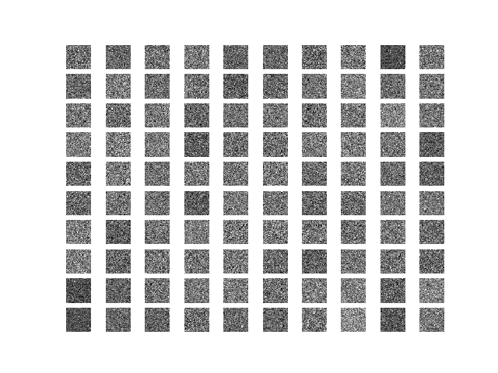

Figure 54. (Part 3) 100 samples of weights (as images) learned at layer 2



Figure 55. (Part 1) 100 samples of weights (as images) learned at layer 3

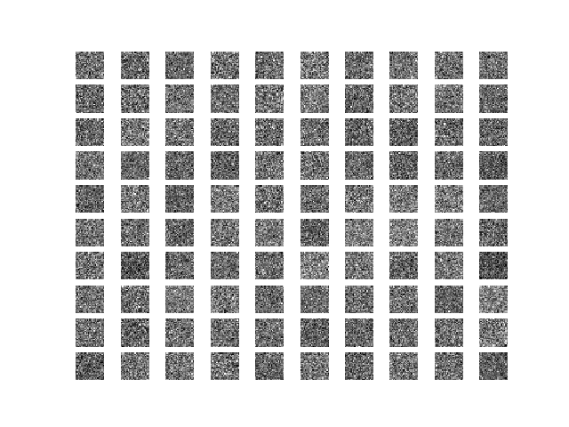

Figure 56. (Part 3) 100 samples of weights (as images) learned at layer 3

### 2.3.2.3 Comparing Reconstructed Images

Figure 57 shows 100 test representatives of reconstructed images in Part (1), and Figure 58 shows the reconstructed images with sparsity constraint and momentum term introduced. With sparsity constraint introduced, the stacked denoising autoencoder is able to reconstruct some distinct features that were not reconstructed in Part (1).



Figure 57. (Part 2) Reconstructed images if 100 representative test images

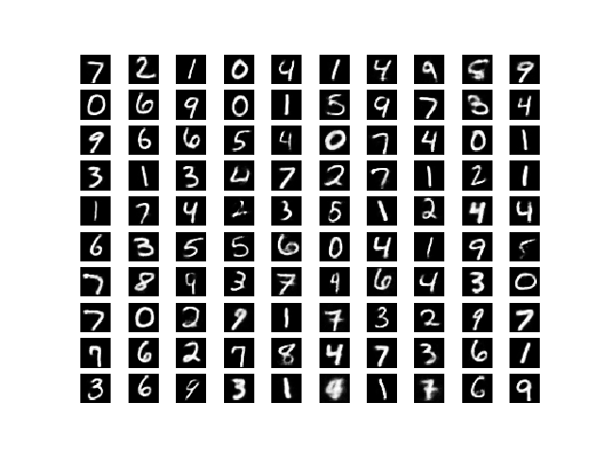

Figure 58. (Part 3) Reconstructed images if 100 representative test images

### 2.3.2.4 Comparing Hidden Layer Activations

The hidden layer activations for Part (2) depicts some noise due to the number of layers present. For the hidden layer activation for Part (3), there are only a few bright spots in Figure 60. This is because with a sparsity constrain, the only a few of the neurons are active. Thus the hidden layer activation becomes sparse too.



Figure 59. Hidden Layer Activation of Network in Part 1

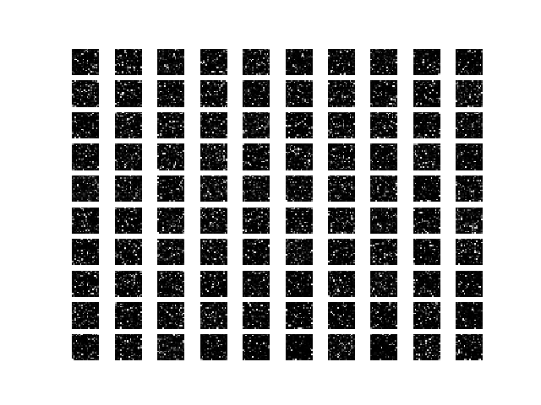

Figure 60. Hidden Layer Activation of Network in Part 3

### 2.3.2.5 Comparing Training Curves of 5-Layer Feedforward Network

Plotting the training curves for the 5-layer feedforward networks, The training errors after 25 epochs are slightly higher in the network with sparsity constrain.

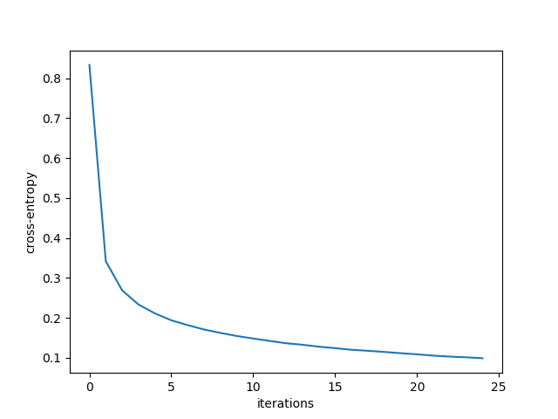

Figure 61 & 62. Training errors for Part 2 (Left) and Part 3 (Right)

### 2.3.2.6 Comparing Test Accuracies of 5-Layer Feedforward Network

Even though both plots for test accuracies are rather similar, the test accuracies for the 5-layer feedforward network with sparsity constrain is slightly lower after 25 epochs. The final test accuracy without sparsity constrain is 0.972 and 0.9681 with sparsity constrain.

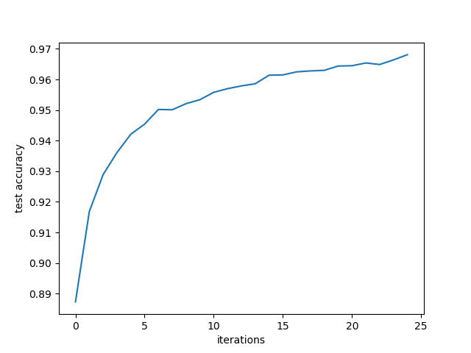

Figure 63 & 64. Test accuracies for Part 2 (Left) and Part 3 (Right)